ASIL NLU Diagnostic Study Report

1. What I tested?
I ran a focused diagnostic suite to determine why the six-head NLU performs poorly on frozen Whisper-large-v3-turbo embeddings:
Experiment | Objective
TF-IDF text baseline vs. Whisper probes | Is the problem fundamentally the frozen Whisper representation or the classification task/data?
Linear + MLP probes | Is useful information present in Whisper embeddings? Is it explicitly separable or non linearly?
Mean vs. attention pooling | Is information being lost by pooling?
Source-dataset probe | Does Whisper encode strong dataset/source-specific information in the embedding space?
Single-task vs. 6-head joint NLU | Is multi-task learning causing interference?
Four balancing strategies | Is class balancing helping or hurting?
Real-only vs. real+synthetic training | Does synthetic TTS damage real-speech generalization?

2. What the results directly showed?
Finding | Result | Direct interpretation
Whisper → Domain | F1 = 1.000 | Domain information is extremely easy to extract
TF-IDF → Domain | F1 = 0.957 | Domain is also easy from transcript
TF-IDF → Intent | F1 = 0.434 | Intent is intrinsically difficult
Whisper → Intent | F1 = 0.399 | Some information is lost relative to clean text
TF-IDF → Entity | F1 = 0.287 | Entity classification is intrinsically difficult
Whisper → Entity | F1 = 0.241 | Some additional information is lost in Whisper representation
TF-IDF → Urgency | F1 = 0.327 | Urgency labels are poorly separable even from clean text
Whisper → Urgency | F1 = 0.283 | Representation contributes some additional degradation
TF-IDF → Emotion | F1 = 0.222 | Text alone is weak for emotion
Whisper → Emotion | F1 = 0.359 | Whisper contains useful affective/acoustic information
Whisper → Source | accuracy = 1.000 | Source/dataset identity is extremely strongly encoded
Embedding NaN/Inf | 0 / 0 | Embeddings are numerically healthy
Test OOV classes | None detected | Missing train classes are not the explanation
Transcript leakage | None detected | Split leakage is not the explanation
Joint vs Single Task F1 difference:  (+ indicates Joint Task performed better, - indicates otherwise) | Domain: 0  Subdomain: -0.003  Intent: +0.012  Entity: +0.016  Urgency: -0.005  Emotion: -0.001 | Too small difference six head multi tasking is not affecting classification performance
No Balancing vs Sampler vs Weighted Loss vs Sampler + Weighted Loss (F1) | No Balancing: 0.4597  Weighted Loss: 0.4540  Sampler: 0.4332  Sampler+Weighted Loss | Balancing is counter productive and should be dismissed. Aggressive re-weighting can amplify sparse/atypical examples without improving generalization.

3. Source/dataset confounding — major finding!

Whisper embedding → source dataset = 100% accuracy. A simple Logistic Regression classifier could identify the originating dataset using only the 1280-D Whisper embedding.
The PCA visualization independently showed strong source-specific clustering:
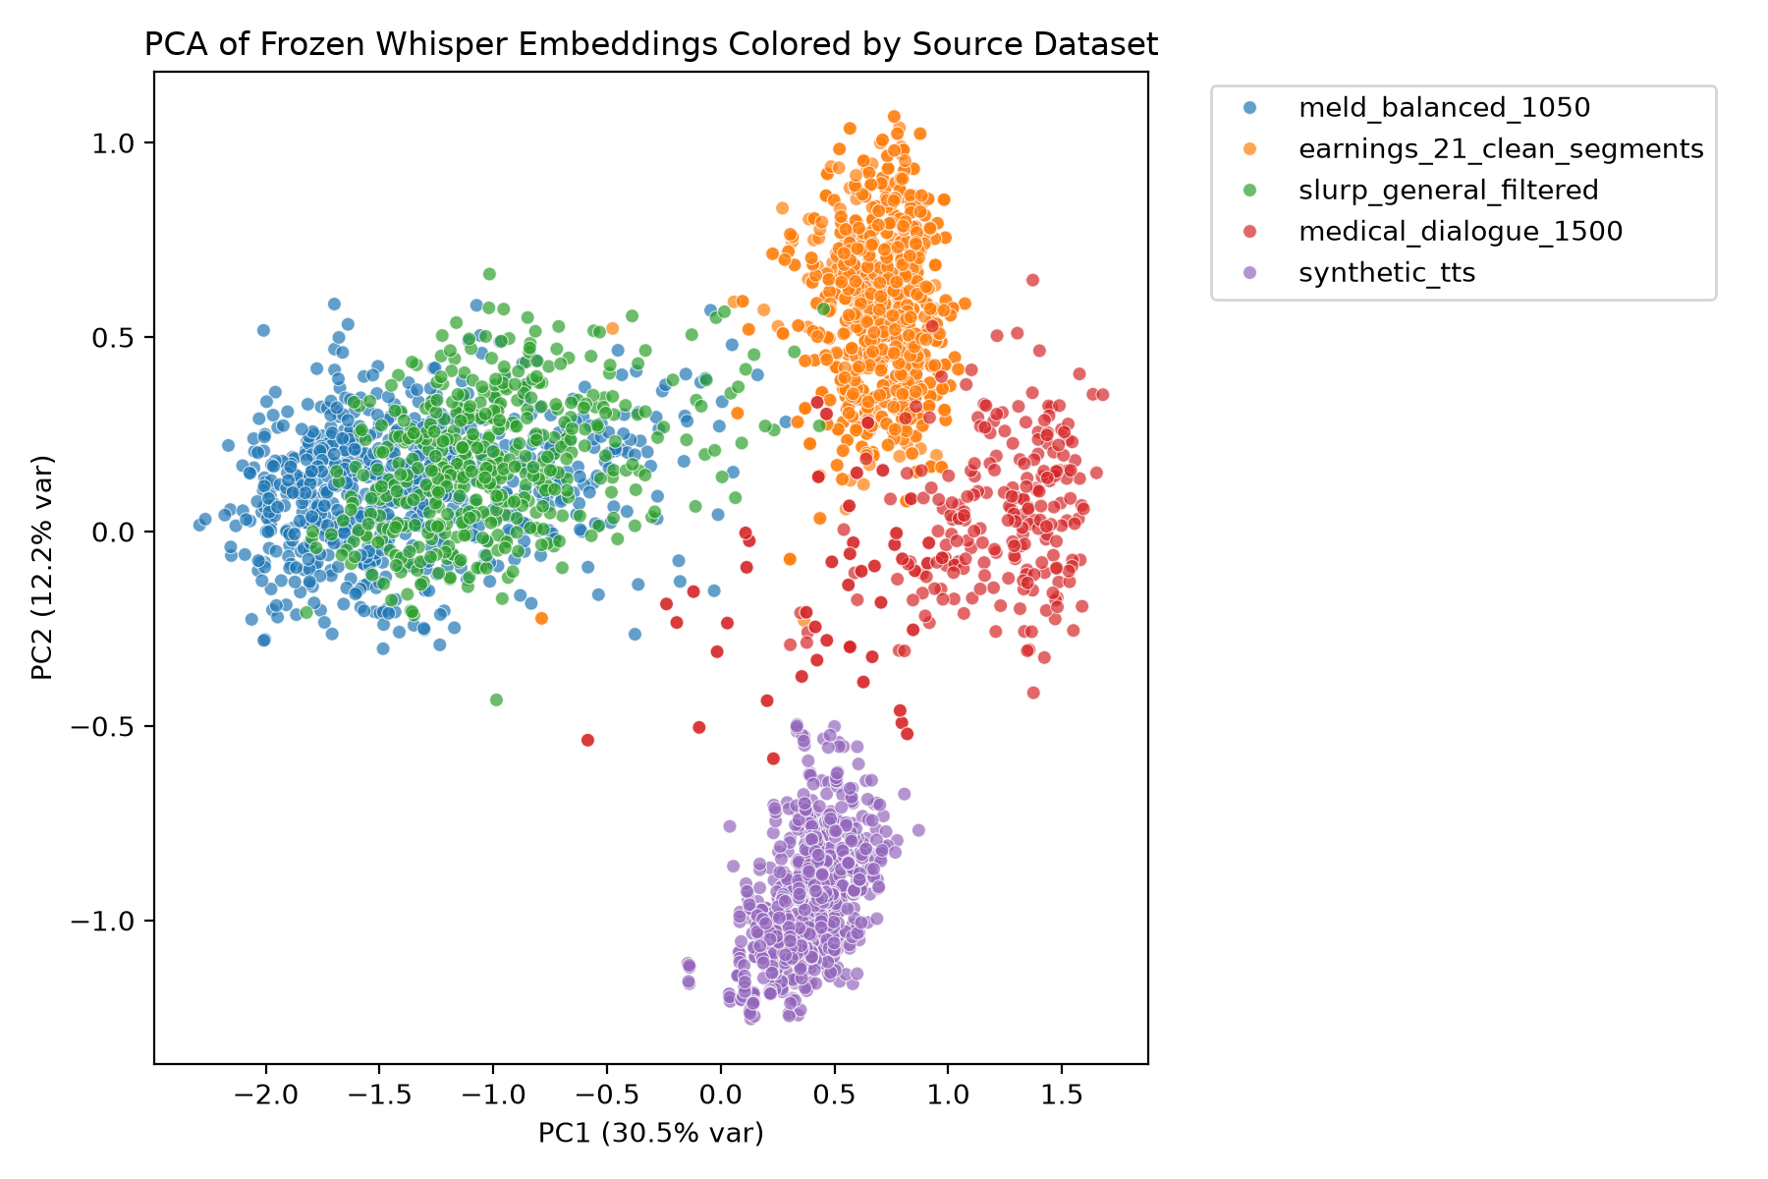
This means the embedding contains substantial information related to dataset/source identity. However, I am not sure if we cannot claim this is purely acoustic leakage. Source information may reflect acoustics, speakers, recording conditions, vocabulary, linguistic style, domain and dataset construction.
Important implication: Domain F1 = 1.0 is not sufficient evidence of genuine domain understanding, because domain and dataset source are strongly correlated.

4. What is actually causing the poor NLU results?

The evidence points primarily to three interacting problems:

1. Label/task conditioning is the biggest problem

Intent, entity and urgency are intrinsically difficult even using clean ground-truth transcripts:
Intent: 0.434 | Entity: 0.287| Urgency: 0.327
Therefore, simply changing Whisper pooling, adding another acoustic encoder, or increasing MLP complexity could not solve the underlying label separability problem.

The current ontology contains semantically overlapping classes and relatively small tail classes.

2. Whisper representation contributes additional loss for some heads
For intent, urgency, entity-type (based on above table), Whisper causes some degradation for intent/entity/urgency, but it is not the primary explanation, because even perfect text performs poorly. Conversely, Whisper is actually better than TF-IDF for emotion.

3. Dataset/source structure is extremely strong

Source probe = 100% and PCA shows strong clustering.
Therefore the current dataset is not a clean demonstration of domain-independent NLU. The model can potentially exploit source-correlated characteristics.

5. What am I doing now?

Primary correction: rebuild the label ontology

We will take the existing ~4.7k-row canonical dataset and use Gemma-assisted semantic relabeling:
Existing 4.7k labels
↓
Deterministic normalization
↓
Gemma semantic grouping
↓
Small finite canonical ontology
↓
Frequency + semantic-boundary constraints
↓
Remove/merge unusable tail classes
↓
Generate additional samples ONLY where
a semantically important class remains under-supported
↓
FINAL CANONICAL LABELS
↓
Automatically remap every row
↓
Retrain the same 6-head NLU

The crucial constraint is:
-not to return thousands of intent/entity classes or create another severely imbalanced ontology.
-Each retained class must have clear semantic meaning, enough examples for MLP learning, meaningful distinction from neighbouring classes & reasonable class frequency.

